**SNIATM Swordfish Datadog Sample Integration Installation Documentation**

Introduction:

### What is Datadog?

Datadog is a monitoring service for cloud-scale applications, bringing together data from servers, databases, tools, and services to present a unified view of an entire stack. These capabilities are provided on a SaaS-based data analytics platform.

Datadog lets you collect all these metrics, events, and service states in one place. Then, visualize and correlate the data with beautiful graphs, and set flexible alerting conditions on it—all without running any storage or monitoring infrastructure yourself.

Datadog helps developers and operations teams see their full infrastructure – cloud, servers, apps, services, metrics, and more – all in one place. This includes real-time interactive dashboards that can be customized to a team’s specific needs, full-text search capabilities for metrics and events, sharing and discussion tools so teams can collaborate using the insights they surface, targeted alerts for critical issues, and API access to accommodate unique infrastructures.

### What is the SNIA Swordfish Sample Integration Dashboard for Datadog?

There are two functional components that, together, make up the SNIA SwordfishTM Datadog Sample Integration Dashboard functionality: the Datadog agent that collects information from the Swordfish APIs on the storage systems, and the Swordfish dashboard capability in the Datadog monitoring service.

Datadog Agent:

The Datadog Agent is a piece of software that runs on any host (or set of hosts if high availability configuration is required). Its job is to faithfully collect events and metrics and bring them to Datadog in order to present and manipulate the monitoring and performance data within the dashboard. The Datadog Agent is open source; view the source code on GitHub.

Swordfish Dashboard sample functionality:

* Swordfish Dashboard views: Capacity data and threshold values for different collections like Volumes, Storage pools and filesystems.
* Data Collection: Using different custom metrics, data-dog will collect all the required data and visualize it in to a Graph or Gauge

## Brief Working Functionality:

* + Install Emulator in local or host machines or vm.
  + Install datadog agent everywhere – vm, server, instances,container- running hosts.
  + Configure datadog to emulator where it’s running
  + Submit custom application metrics by writing code
  + Open https://www.datadoghq.com in browser or user agent.
  + Register and login to https://www.datadoghq.com
  + Create dashboards and show the required data in graphs . Instrument your own gauges, counters, timers and histograms .

### Steps to install and run Datadog Agent:

1. Before installing Datadog, Swordfish Emulator should run in local machine or Server machines.

Refer to Swordfish Installation documentation, we can find steps to install swordfish emulator in windows or linux systems. Steps to configure local machines are described in developers documentation. ( Python and SNIA emulator need to be installed)

1. After installing Emulator we can now install datadog.
2. Login to Datadog web site ( <https://app.datadoghq.com/> )
3. Create API keys and Application keys (<https://app.datadoghq.com/account/settings#api/>)which we have to use in our local services.

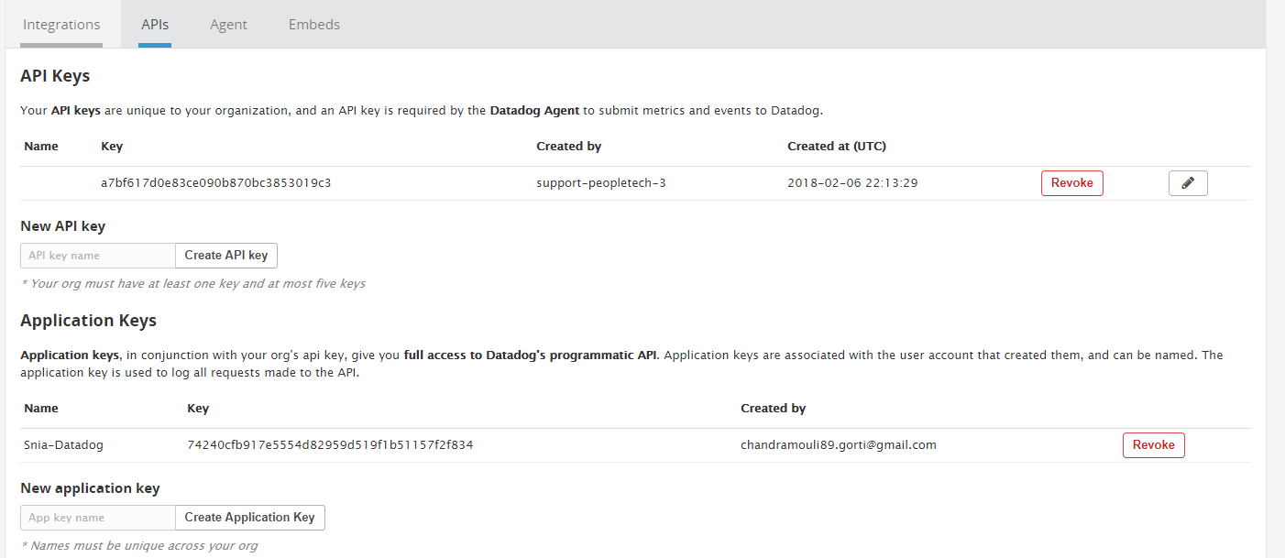

1. Install Datadog to a Local machine

RecommendUbuntu 16.04 (tested configuration)

Windows 7,8 and 10

1. Installation Steps: (Provided information for Ubuntu Linux configuration)

Run the below commands to install datadog in local machine.

* + sudo apt-get update
  + sudo apt-get install apt-transport-https

Set datadog deb repo on local and import datadog api key.

* + sudo sh -c "echo 'deb https://apt.datadoghq.com/ stable 6' > /etc/apt/sources.list.d/datadog.list"
  + sudo apt-key adv --recv-keys --keyserver hkp://keyserver.ubuntu.com:80 382E94DE

Use local apt repo and install the agent

* + sudo apt-get update
  + sudo apt-get install datadog-agent

Place our API key and copy it to config

* + sudo sh -c "sed 's/api_key:.*/api_key: a7bf617d0e83ce090b870bc3853019c3/' /etc/datadog-agent/datadog.yaml.example > /etc/datadog-agent/datadog.yaml"

Start Agent

* + sudo systemctl restart datadog-agent.service

1. StartDatadog :-

Start Agent as a service

* + sudo /etc/init.d/datadog-agent start

Restart agent running as a service

* + sudo /etc/init.d/datadog-agent restart

Status page of running agent

* + sudo /etc/init.d/datadog-agent info

### To Configure Sample Dashboard:

* We will create a new dashboard from right menu of Datadog page.
* After creating dashboard, we can select graphs to visualize the data.

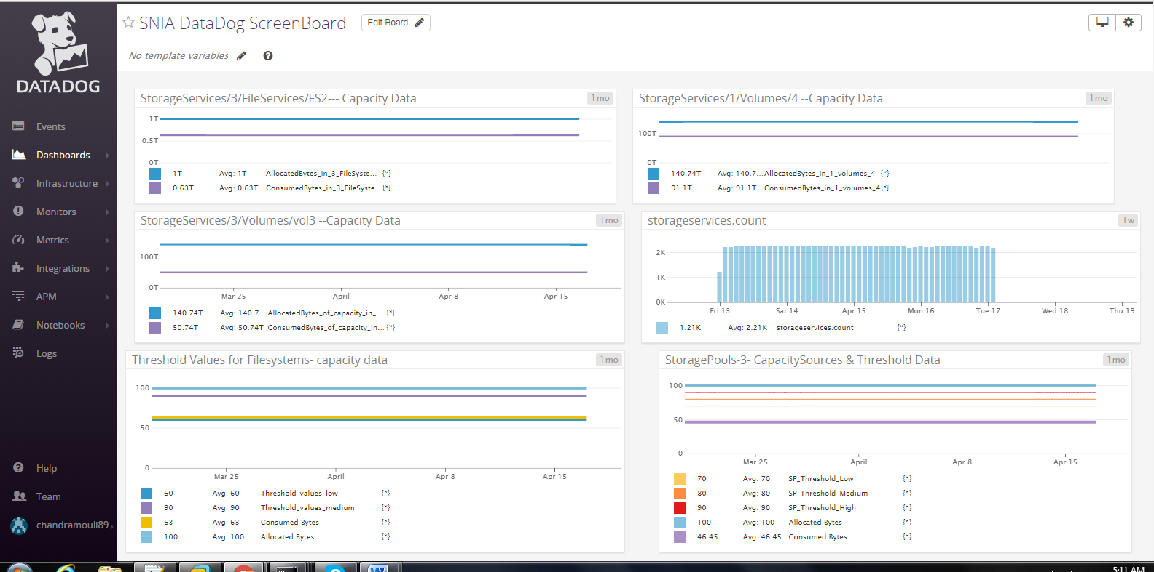

The below is the graph editor window where we can edit the visualization,choose metrics and events, adds filters and add functionalities if requires.

